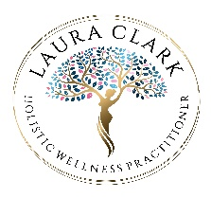

All 1:1 appointments require a minimum of 24 hours notice to reschedule. You can reschedule your healing session by contacting me. If it is less than 24 hours until your appointment time, you will not be able to reschedule or receive a refund and will have to book and pay for an entirely new session.

If you are working with me on an ongoing basis, having booked a block, then all appointments can be rescheduled with 24 hours notice. Just message me.

Thank you for understanding.

Laura